Create a GitHub account. You will need it for the course. Link: <https://github.com/>

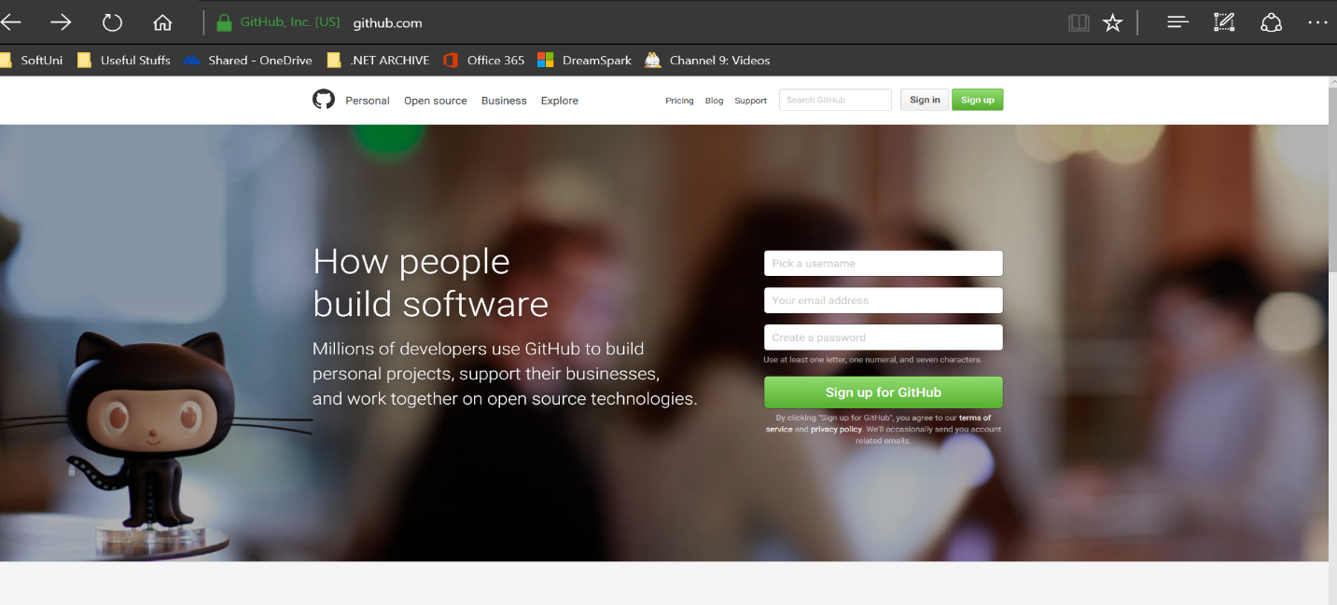

After you verify your account by e-mail you are ready to go. On your profile page search for Repositories.

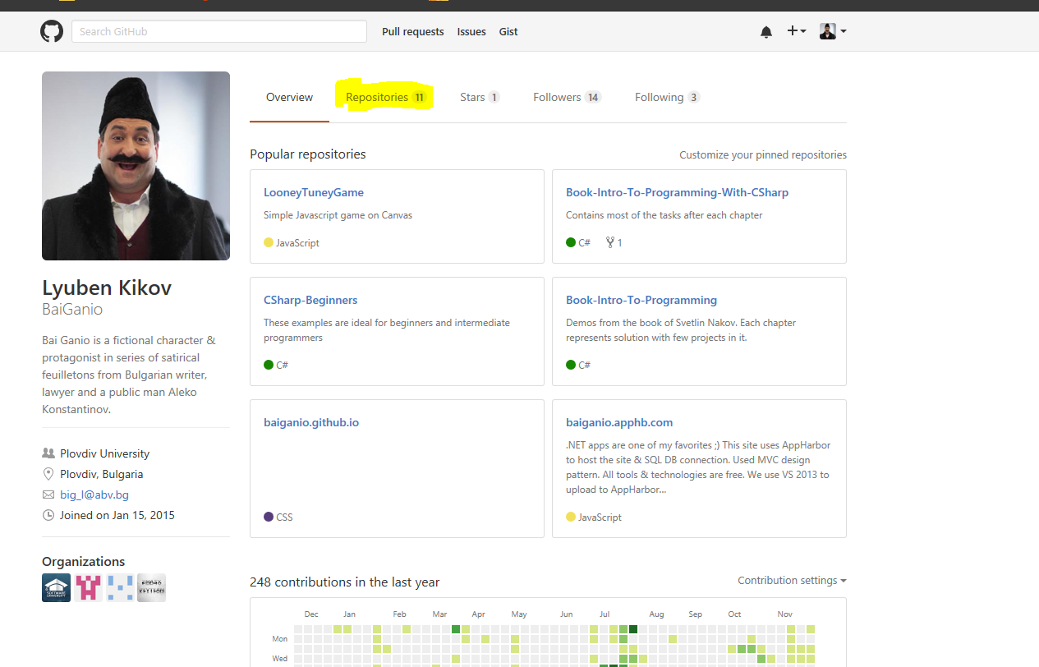

Find the button and create new repo.

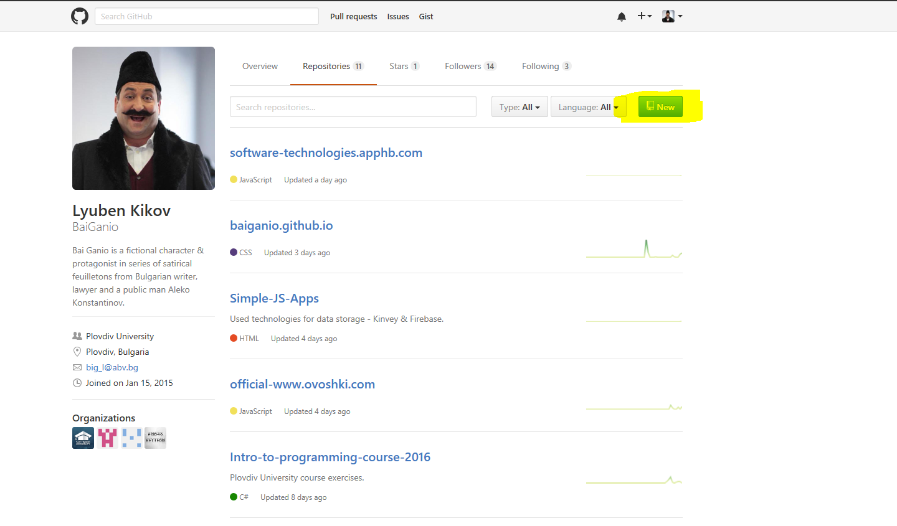

Follow the steps to create your repository.

